[Toomer Elementary]
Date: [November 21, 2019]
Time: [4:30 pm]
Location: [Toomer Library]

- Call to order: [4:36 pm]
- Roll Call
Role | Name (or Vacant) | Present or Absent
Principal | Caroline Brown | Present
Parent/Guardian | Catherine Harper | Present
Parent/Guardian | Celeste Walley-Jean | Present
Parent/Guardian | Bianca Betts | Present
Instructional Staff | JaBria Cooper | Present
Instructional Staff | Kaitlin Clark | Present
Instructional Staff | Khadija Washington | Present
Community Member | Vijay Makar | Absent
Community Member | Neill Davis | Present
Swing Seat | Joseph Wang | Present

Quorum Established: [Yes]
- Action Items (add items as needed)
  - Approval of Agenda: Motion made by: [Neil Davis]; Seconded by: [Celeste Walley Jean]
Members Approving: unanimous
Members Opposing:
Members Abstaining:
Motion [Passes]
- Discussion Items
  - Data Review
  - Strategic Plan Priorities
    - 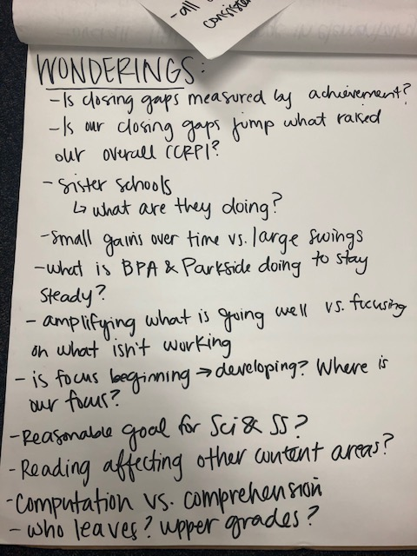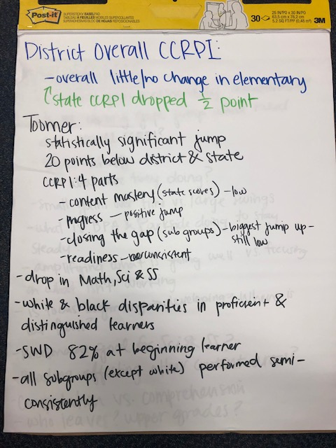
- Information Items
  - Principal’s report: CCRPI Notice & Wonderings
- Announcements
- Public Comment
  - none
- Adjournment
Motion made by: [Kaitie Clark]; Seconded by: [Celeste Walley-Jean]
Members Approving: Unanimous
Members Opposing:
Members Abstaining:
Motion [Passes]
ADJOURNED AT [5:43 PM]
-----------------------------------------------------------------------------------------------------------------------------
Minutes Taken By: [Kaitie Clark ]
Position: [Secretary]
Date Approved: 1/21/2020

